# Creating Deployment Artifacts

Once customizations and configuration are created, it is useful to deploy the Workdesk to other environments, such as QA and Production. This section describes how to create deployment artifacts.

## SQL Database schema and data

1. Open Microsoft SQL Server Management Studio.

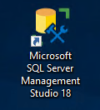

1. Expand Databases in Object Explorer.

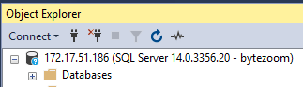

1. Right click on BytezoomWorkdesk database.
2. Select Tasks > Generate Scripts.

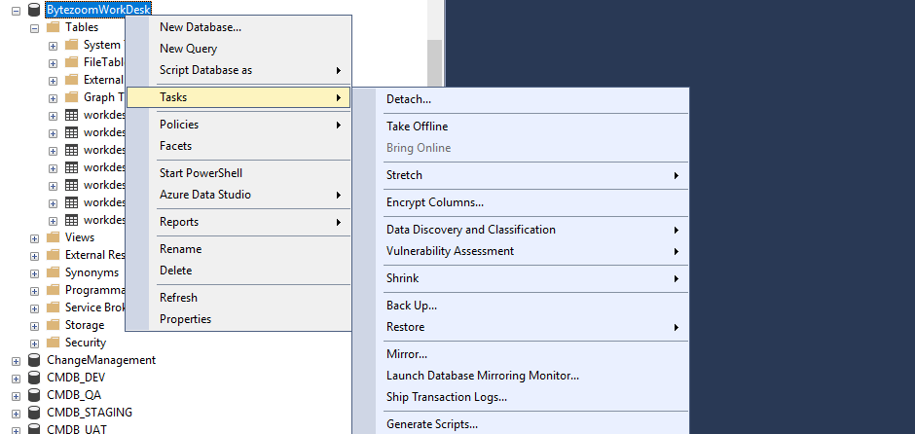

1. Click Next.



1. Click Next.



1. Click Advanced.



1. Set Types of data to script to Schema and Data.



1. Click OK.



1. Set File Name to script.sql.



1. Click Next.



1. Click Next.



1. Click Finish.



## K2 Forms, views and SmartObjects

1. Open K2 Package and Deployment.

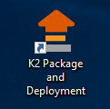

1. Select DEV server.



1. Click Create New Package.



1. Set Package Name to BytezoomWorkdesk.



1. Click Next.



1. Click Add Item.



1. Select Bytezoom Workdesk folder.



1. Click OK.



1. Click Finish.



# Bytezoom Workdesk Deployment

## SQL database schema and data

1. Open Microsoft SQL Server Management Studio.



1. Right Click on Databases in ObjectExplorer.



1. Select New Database.



1. Set Database name to BytezoomWorkdesk.



1. Click OK.



1. Open script.sql.

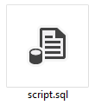

1. Click Execute.



## Service Instance

1. Open SmartObject Service Tester.

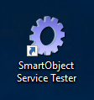

1. Click Register ServiceInstance.



1. Set Service Types to SQL Server Service.



1. Set AuthenticationMode to ServiceAccount.



1. Set Database to BytezoomWorkdesk.



1. Set Database to sql01-n.



1. Click Next.



1. Set Guid to 531f1e55-b8cc-4537-87ee-71f551b39327.



1. Click Add.



1. Click OK.



## K2 Forms, views, SmartObjects

1. Open K2 Package and Deployment.



1. Select QA/PROD server in K2 Package and Deployment.
2. Click Deploy Package.



1. Click Browse.



1. Select package BytezoomWorkdesk.kspx.
2. Click Open.



1. Click Next.



1. Click Next.



1. Click Finish.

